Dunman High School
2010 Year 6 Prelim Exam (H1 Chemistry) Paper 2 – Answers

Section A

Answer all the questions in this section in the spaces provided.

1(a) It has always been stated that the elements of the Periodic Table show general trend from metallic to non–metallic behavior, coupled with an increase of oxidation state of their compounds.
+8
+7
+6
+5
+4
+3
+2
+1

Na Mg Al Si P S Cl
= oxidation state of Period 3 elements in oxides

(i) Mark with a cross (X) on the diagram the highest oxidation state of the oxide of chlorine.

(ii) Magnesium and aluminium are both metals. Explain, with the aid of appropriate equations, why magnesium oxide reacts with only acids but aluminium oxide reacts with both acids and bases.

Magnesium acts as a basic oxide and reacts with acids only.
MgO (s) + 2HCl (aq) → MgCl₂ (aq) + H₂O (l)
Aluminium oxide acts as an amphoteric oxide and reacts with both acids and bases.
Al₂O₃ (s) + 6HCl (aq) → 2AlCl₃ (aq) + 3H₂O (l)
Al₂O₃ (s) + 2NaOH(aq) + 3H₂O(l) → 2NaAl(OH)₄ (aq)
[4]

1(b) Magnesium oxide, phosphorus pentoxide and phosphorus pentachloride all exists as white solids. Suggest reactions you could carry out to distinguish between the three compounds, writing equations where appropriate.

Add a sample of each compound to a solution of litmus (or Universal Indicator) in water.
For MgO, the solution turns blue.
MgO + H₂O 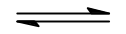 Mg(OH)₂
For P₄O₁₀ and PCl₅, the solution turns red.
P₄O₁₀ (s) + 6 H₂O (l) → 4 H₃PO₄ (aq) {ss not required}
For PCl₅, white fumes are also observed.
PCl₅ (l) + 4H₂O (l) → H₃PO₄ (aq) + 5HCI (aq)
[3]

(c) Phosphorus pentachloride can undergo decomposition at high temperature to form phosphorus trichloride and chlorine. This reaction is known to be a first–order reaction.
PCl₅(g) PCl₃(g) + Cl₂(g)

(i) Explain what is meant by first–order reaction.
A reaction is said to be first order with respect to a particular reactant, A if the rate of reaction is directly proportional to [A]

(iii) Given that the rate constant for the reaction is 1.55 x 10^{–3} s^{–1}, calculate the time taken for the concentration of PCl₅(g) to decrease from 1 mol dm^{–3} to 0.125 mol dm^{–3}.

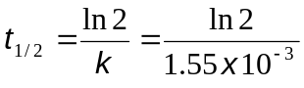
= 447.2 s
Time taken = 447.2 x 3
= 1340 s (3s.f)
[3]

[Total: 10]

2. Ethanoic acid, an important industrial commodity chemical in the world, finds a variety of uses in vinegar, polymer formation and ester formation.

(a) In an experiment, 20.0 cm³ of 0.250 mol dm^{–3} barium hydroxide, a strong base, is titrated against an aqueous solution of ethanoic acid. The following titration graph is obtained.
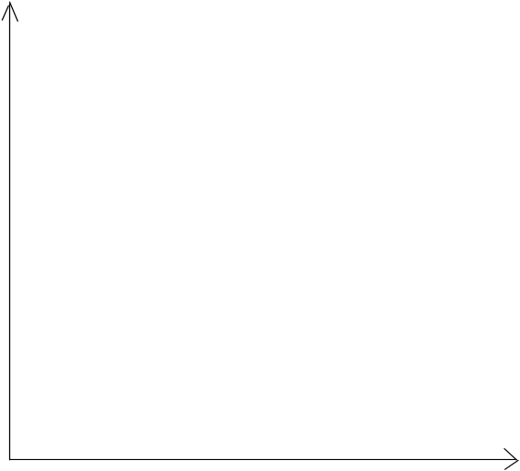
V_{acid} added/ cm³
pH
0
15.0

(i) Write a balanced chemical equation for the reaction between ethanoic acid and barium hydroxide.

2CH₃CO₂H (aq) + Ba(OH)₂ (aq) → (CH₃CO₂–)₂Ba²⁺ (aq) + 2H₂O (l)

(ii) Calculate the pH of barium hydroxide solution.

[OH–] = 0.250 x 2 = 0.500 mol dm^{–3}
pOH = –log[OH–] = log(0.500) = 0.3010
pH = 14 – pOH = 13.7

(iii) Calculate the initial concentration (in mol dm^{–3}) of the ethanoic acid.

n_{OH–} = (20.0/1000 x 0.250) = 0.00500 mol
n_{CH3COOH} = 2n_{OH–} = 0.0100 mol

[CH₃COOH] = 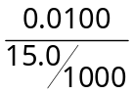= 0.667 mol dm^{–3}

(iv) Suggest a suitable indicator for this titration.

Phenolphthalein

(v) After 30 cm³ of ethanoic acid is added to the mixture, the solution is able to resist pH changes when a small amount of acid or alkali is added. Write two equations to explain why this is so.

CH₃CO₂⁻ (aq) + H⁺ (aq) → CH₃CO₂H (aq)
CH₃CO₂H (aq) + OH⁻ (aq) → CH₃CO₂⁻ (aq) + H₂O (l)
[6]

(b) Aspirin, also known as acetylsalicylic acid, is a salicylate drug, often used as an analgesic to relieve minor aches and pains, as an antipyretic to reduce fever, and as an anti–inflammatory medication. The structure of aspirin is as shown below.

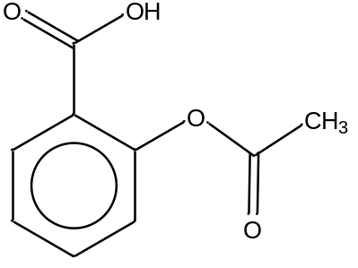

Aspirin

(i) Give the reagents and conditions to produce ethanoic acid from aspirin.

Aqueous NaOH/KOH, heat, followed by acidification with aqueous H₂SO₄/HCl
OR
Aqueous H₂SO₄/HCl, heat. [1 or 0]

(ii) Explain why aspirin is insoluble in water.

Aspirin is insoluble in water due to presence of the large hydrophobic benzene ring
and no favourable solute–solvent interaction can be formed with water molecules.

(iii) However, aspirin is soluble in aqueous sodium hydroxide at room temperature. Explain, with the aid of an equation, why this is so.

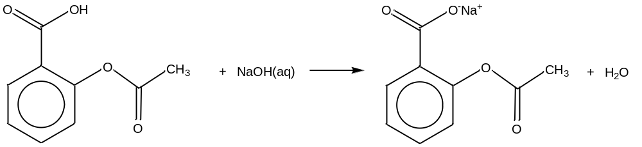

In NaOH(aq), aspirin forms an ionic salt which is able to form ion–dipole interactions with water molecules. Hence, it is soluble in water.
[4]
[Total: 10]

3(a). Nitrogen trichloride is a yellow, oily, pungent–smelling liquid is most commonly encountered as a byproduct of chemical reactions between ammonia–derivatives and chlorine. It is also used as a bleaching agent for flour in the Agene process. An energy level diagram involving nitrogen trichloride is shown below.
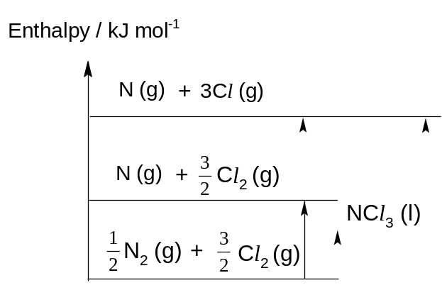
ΔH_{at}^{θ}(N₂)

(i) Define the term standard enthalpy change of formation.

Standard enthalpy change of formation (ΔH_{f}^{θ}) of a substance is the energy change when one mole of the substance is formed from its elements under standard conditions.

(ii) Using ΔH_{f}^{θ}(NCl₃), bond energy (N–Cl) and bond energy (Cl–Cl), label the enthalpy changes of the processes involved on the energy level diagram above.

Award 1m for each correct label.
(iii) Hence, use the information given below and relevant data from the Data Booklet to calculate the bond energy of N–Cl bond.

ΔH_{f}^{θ}( NCl₃) = +232 kJ mol^{–1}
BE (N–Cl) = [–232 + (994) + (244)] /3
= +210 kJ mol^{–1}
[6]

(b) A student used the apparatus below to determine the enthalpy change of combustion of propan–1–ol. It was found that 0.60 g of propan–1–ol was used to raise the temperature of 200 g of the water. The initial temperature of the water was 21.0 °C.
The specific heat capacity of water is 4.18 J g^{–1} K^{–1}.

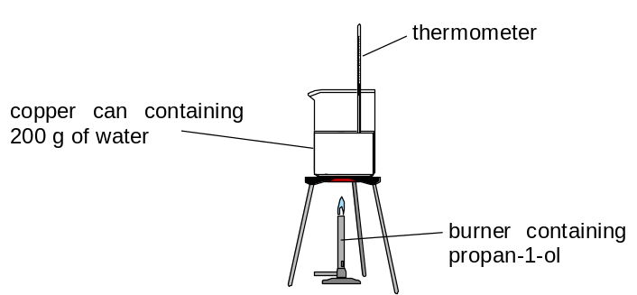

(i) Calculate the number of moles of propan–1–ol burnt.

Number of moles of propan–1–ol burnt = 0.60 / [3(12.0) + 8(1.0) + 16.0)]
= 0.010 mol

(ii) Given that the enthalpy of combustion of propan–1–ol is –2021 kJ mol^{–1}, calculate the final temperature of water at the end of the experiment.

Amount of heat liberated from combustion
= 0.010 x 2021
= 20.21 kJ
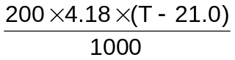 = 20.21
T_{f} = 45.1°C

(iii) The actual temperature of the water measured at the end of experiment is 38.0 °C. Give an explanation for the difference.

Heat loss to surroundings or incomplete combustion of propan–1–ol resulting in less heat produced.
[4]

[Total: 10]
4 Acrolein is formed when fats or vegetable oils are cooked at high temperatures. In fried foods, it may upset the stomach.

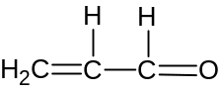

(a) (i) Name the functional group(s) found in acrolein.

Alkene, aldehyde

(ii) Give the IUPAC name for acrolein.

Propenal
[2]
(b) The C=O and C=C bonds have the same electronic structure and they undergo typically addition reactions.

(i) What do you understand by the term ‘addition’?

‘Addition’ means to gain an atom or group of atoms ,without any loss of atom(s) in the reaction.

(ii) Suggest suitable reagent and conditions to bring about an addition reaction of the C=O bond.

 |  | Reagent for C=O: | HCN, NaOH (aq), 10 – 20 °C
[2]

(c) Draw the structural formula of the product(s) formed when acrolein reacts with the following reagents. Include the formula of other products formed (if any).

(i) | hydrogen in platinum catalyst |  | 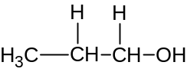 or CH₃CH₃CH₂OH
(ii) | acidified potassium dichromate |  | 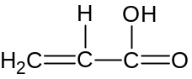 + Cr³⁺
(iii) | Fehling’s solution |  | 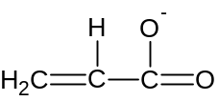 + Cu₂O + H₂O

(d) Methacrolein is a clear colourless flammable liquid that has a similar structure to acrolein.
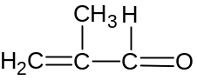

There are two isomers of methacrolein, S and T, both of which react differently when subjected to alkaline aqueous iodine and Tollens’ reagent.

Like methacolein, S forms a precipitate with Tollens’ reagent but not with alkaline aqueous iodine.

On the other hand, T forms a precipitate with alkaline aqueous iodine but not with Tollens’ reagent.

(i) What deduction can you make about the isomers when a precipitate is formed upon reacting with

- alkaline aqueous iodine, and
Compound contains structure CH₃CO– or CH₃CH(OH)–

- Tollen’s reagent
Compound is an aldehyde.

(ii) Use your deductions to propose the structures of S and T.
 |  | S:  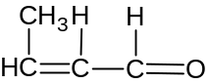 | T:  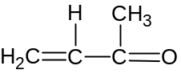

[3]

[Total: 10]

Section B

Answer two questions from this section on separate answer paper.

1(a) Chlorine is a common element which can be found in many inorganic as well as organic compounds. The most common isotope of chlorine is 35–chlorine.

- Write the symbol (include mass number) of the other isotope of chlorine and calculate the relative abundance of this isotope.

³⁷Cl .
Let x be the relative isotopic abundance of ³⁵Cl .
35x + (1–x)37 = 35.5
x = 0.75
⇒ relative isotopic abundance of ³⁵Cl is 75%
relative isotopic abundance of ³⁷Cl is 25%

  - Write an equation to represent the first ionisation energy for chlorine.
Cl(g) → Cl⁺(g) + e

  - Using the Data Booklet, explain the difference in first ionisation energy between chlorine and bromine.

First ionisation of chlorine = +1260 kJ mol^{–1}
First ionisation of bromine = +1140 kJ mol^{–1}
- Both nuclear charge (no. of protons) and screening effect (no. of shells) increases.
- The significant increase in screening effect outweighs increase in nuclear charge.
- Hence, effective nuclear charge decreases down the group.
- As a result, there is weaker electrostatic attraction between nucleus and valence/outermost electrons.
- Valence/outermost electrons are thus further away from the nucleus down the group.
- Lesser amount of energy needed to remove the valence electron.
[7]

(b) Chlorine can form an ionic compound with Group I and II metals. The table below shows the lattice energies of three chlorine based ionic compounds.

Ionic compound | Lattice energy/ kJ mol^{–1}
potassium chloride | –701
calcium chloride | –2237

- Define the term lattice energy.
Lattice energy of an ionic crystal is the energy evolved when one mole of the solid ionic compound is formed from its constituent gaseous ions under standard conditions.

- Explain the difference in the lattice energy between potassium chloride and calcium chloride.

The ionic radius of calcium ion is smaller than potassium ion and hence a smaller cationic size.
Size of charge or calcium ion is greater than that of potassium ion.
Since lattice energy ∝ 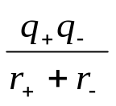, calcium chloride will have more negative lattice energy than potassium chloride.

- Calcium ion and chloride ion is subjected to the effect of an electric field as shown below. Copy this diagram, and draw and label clearly the path of the ions under the influence of the electric field.

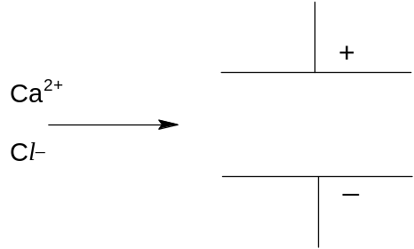
Cl–
Ca²⁺
1m each for correct arrow pointing to correct plate.
1m for greater angle of deflection for Ca²⁺.

[6]

(c) The commercial insecticide DDT is an organochlorine first discovered by Swiss chemist Paul Hermann Müller. It is nearly insoluble in water but very soluble in organic solvents and fats.
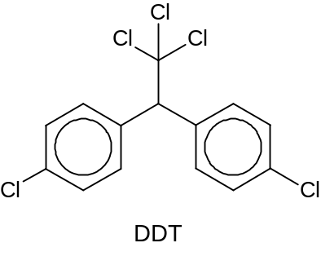
Consider the reaction scheme given below.

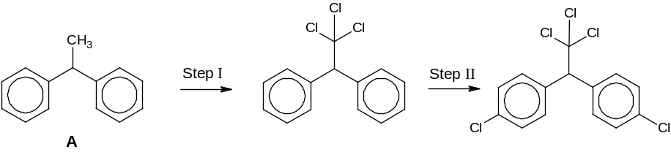

- Provide the reagents and conditions required for Step I and II.

Step I: Cl₂(g) in the presence of uv light.
Step II: Cl₂(g), AlCl₃ in the absence of light

- Predict and explain if Compound A or DDT will have a higher melting point.

DDT is predicted to have a higher melting point
Both compound A and DDT are simple molecular structures
DDT has stronger intermolecular van der Waals’ forces of attraction due to permanent dipole–dipole interactions.
OR
DDT has larger number of electrons
resulting in stronger induced dipole–induced dipole interaction
Larger amount of energy is required during melting

- Why is the compound 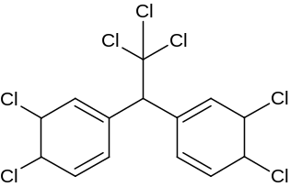 not formed in Step II?

Benzene ring will not undergo addition reaction since it will destroy the stable aromatic character of benzene.

- Draw the structural formula of the product formed when DDT reacts with excess aqueous sodium hydroxide assuming chlorobenzene will not react.

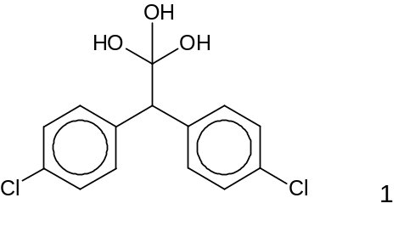
[7]

[Total: 20]

2. Methane is used to produce synthesis gas (syngas), a mixture that includes carbon monoxide and hydrogen, by reacting with steam on a nickel catalyst. Syngas is then used to produce liquid hydrocarbons and methanol.
CH₄ (g) + H₂O (g) CO (g) + 3H₂ (g)
A total of 5 mol gas mixture comprising of methane and steam is mixed in 1:1 ratio in a
2 dm³ vessel. After some time, 1 mol of methane is found to be remaining at equilibrium.

(i) How many moles of methane have reacted? Calculate the number of moles of steam reacted as well as that of carbon monoxide and hydrogen gas produced.
Initial (n)_{methane} = ½ x 5 = 2.5 mol

(n)_{methane} reacted = 2.5 – 1 = 1.5 mol

Since CH₄ ≡ H₂O ≡ CO ≡ 3H₂

(n)_{steam} reacted = 1.5 mol

(n)_{CO} produced = 1.5 mol

(n)_{hydrogen} produced = 3(1.5) = 4.5 mol

(ii) Write an expression for the equilibrium constant, K_{c} and determine its value, including units.
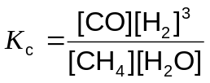 = 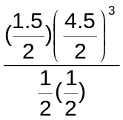 = 34.2 mol dm^{–3}

(iii) It is known that this reaction is an endothermic process. What is meant by the term in italics?
Endothermic means that heat/energy is absorbed from the surrounding.

(iv) Predict and explain the effect of separately increasing pressure and decreasing temperature on the above equilibrium as well as on the yield.
On increasing the pressure,
by Le Chatelier’s Principle, the position of equilibrium will shift to the left to reduce the total number of moles of gas.

On decreasing the temperature,
by Le Chatelier’s Principle, the position of equilibrium will shift to the left towards the exothermic reaction to release heat.

In both cases, yield decreases.

(v) In practice, a moderately high pressure is used in the production of syngas. Suggest a reason for this.
Using too high a pressure is expensive / costly due to thick pipes needed, or
it increases rate of reaction , or
too high a pressure will result in low yield ,
hence a moderately high pressure is used instead.

(vi) Sketch a graph showing how the rates of the forward and reverse reactions change with time, from the point of mixing to the point after equilibrium is established. Label your graphs clearly.
Forward
reaction
rate
time
At t_{eqm}:
Rate of forward = rate of backward reaction
Backward
reaction
t_{eqm}

[13]
(b) To manufacture methanol, the carbon monoxide and hydrogen mixture is passed over a mixutre of copper, zinc oxide and alumina catalyst. Besides being a common laboratory solvent, the largest use of methanol (CH₃OH) is to produce methanal (HCHO).

(i) Industrially, oxygen is used to react with methanol to produce methanal. Write an equation for this reaction.

CH₃OH + ½O₂ → HCHO + H₂O

(ii) Alternatively, what reagent(s) and condition(s) can be used in the laboratory to convert methanol to methanal?

K₂Cr₂O₇ in dilute H₂SO₄, heat with distillation

(iii) Sketch the shape of the hybrid orbitals around the carbon in methanal molecule.

HCHO:

sp²
[3]

(c) A sample of methane reacts with excess bromine to form a mixture of brominated products.

(i) Identify the type of reaction that has occurred.

Free radical substitution

(ii) One of the products is found to have the composition by mass: C, 6.9%; H, 1.2% and Br, 91.9%. Draw the displayed formula of this product.

 | C | H | Br
% mass | 6.9% | 1.2% | 91.9%
No. of mol | 6.9/12  = 0.575 | 1.2 | 91.9/(79.9) = 1.15
Ratio | 1 | 2 | 2

Product is: CH₂Br₂ ⇒ displayed formula: | 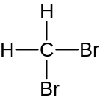

(iii) Write the structural formulae of two other brominated products.

Other products: CH₃Br, CHBr₃, CBr₄

[4]

[Total: 20]
3(a) The oxo reaction is an important industrial process in which an alkene combines directly with carbon monoxide and hydrogen under suitable conditions. The reaction with ethene is shown below.
catalyst
high T, p
CH₂=CH₂ + CO + H₂ CH₃CH₂CHO

(i) What is the simple relationship between the time taken for the reaction and the initial rate of the reaction?
Time taken for the reaction is inversely proportional to the initial rate of the reaction or time taken α 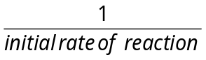
(ii) A series of experiment is carried out to investigate the kinetics of the oxo reaction with ethene. The following results are obtained.
Experiment | [CH₂=CH₂]  / mol dm^{–3} | [CO] / mol dm^{–3} | [H₂] / mol dm^{–3} | Time / s
1 | 0.200 | 0.100 | 0.500 | 500
2 | 0.400 | 0.200 | 0.250 | 250
3 | 0.400 | 0.200 | 0.500 | 125

It was determined that the order of reaction with respect to carbon monoxide is 1.
(I) Calculate the initial rate for each of the three experiments and use the results to determine the order of reaction with respect to CH₂=CH₂ and H₂.
Initial rate for Experiment 1 = 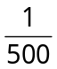 = 2.0 x 10^{–3} s^{–1} or mol dm^{–3} s^{–1}
Initial rate for Experiment 2 = 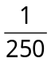 = 4.0 x 10^{–3} s^{–1} or mol dm^{–3} s^{–1}
Initial rate for Experiment 3 = 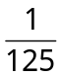 = 8.0 x 10^{–3} s^{–1} or mol dm^{–3} s^{–1}
Comparing Experiment 2 and 3, while keeping [CH₂=CH₂] and [CO] constant,
When [H₂] doubles, initial rate of the reaction also doubles.
Hence it is 1st order of reaction with respect to H₂.
Comparing Experiment 1 and 3,
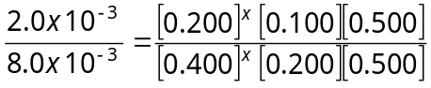
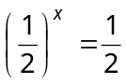 → x =1
Hence it is 1st order of reaction with respect to CH₂=CH₂.

(II) Hence write a rate equation for the reaction and calculate a value for the rate constant, giving its units.
rate = k[CH₂=CH₂][CO][H₂]
Using Experiment 1,
2.0 x 10^{–3} = k(0.200)(0.100)(0.500)
k = 0.200 mol^{–2} dm⁶ s^{–1} or mol^{–3} dm⁹ s^{–1}

(iii) Draw the structural formula of the product of the oxo reaction if the starting alkene is but–2–ene instead.

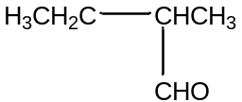
[8]

(b) Propanal can be prepared from chloroethane under laboratory conditions, using propanoic acid as an intermediate. Propose a reaction scheme, in not more than 4 steps, for this conversion. Your answer should include the reagents and conditions, as well as the structures of the intermediate compounds formed. [3]

CH₃CH₂Cl CH₃CH₂CN CH₃CH₂COOH
alcoholic KCN, reflux aq HCl, reflux
LiAlH₄ in dry ether
CH₃CH₂CHO CH₃CH₂CH₂OH
K₂Cr₂O₇, H₂SO₄,
heat with distillation

(c) Both ethanol and chloroethane can undergo a similar reaction to form ethene but using different reagents and conditions.
(i) Suggest the name of this reaction.
Elimination

(ii) Give the reagents and conditions to form ethene from ethanol and chloroethane respectively. [3]

Ethanol to ethene – concentrated H₂SO₄, 170 °C
Chloroethane to ethene – ethanolic NaOH, reflux

(d) While Sean is doing his experiment in the laboratory, the labels of 3 test–tubes each containing 1–phenylethanol, 1–bromoethylbenzene and 1–chloroethylbenzene dropped off. The structures of the 3 compounds are shown below:
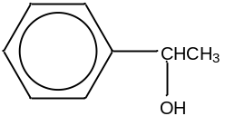 | 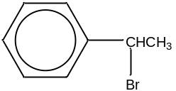 | 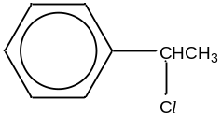
1–phenylethanol | 1–bromoethylbenzene | 1–chloroethylbenzene

(i) Suggest how Sean can carry out 2 different tests to distinguish the 3 compounds from one another. For each test, state the reagents and conditions, and give the observations you would make with each compound undergoing the test.

Test 1: Add PCl₅ (g) at r.t or alkaline aqueous iodine and warm.
Observations: 1-phenylethanol will produce white fumes of HCl.
The other 2 compounds will not produce white fumes of HCl
Test 2: Add aqueous NaOH and heat, followed by aqueous nitric acid and silver nitrate.
Observation: 1-bromoethylbenzene will produce a cream ppt while
1-chloroethylbenzene will produce a white ppt.

(ii) Both 1–bromoethylbenzene and 1–chloroethylbenzene can react with ethanolic ammonia to form amines. Predict and explain which of the two compounds will have a faster reaction with ethanolic ammonia. [6]

1-bromoethylbenzene will have a faster reaction with ethanolic ammonia due to its longer bond length and hence weaker bond strength. Hence the C-Br bond will be broken more easily and 1-bromoethylbenzene will undergo nucleophilic substitution more easily.
[Total: 20]

